SMART CARE

Submitted by
ANJANA SOMAN
ATHIRA N KAIMAL
DEVIPRIYA U
LAVANYA J
ABSTRACT
The Smart Care system is aimed to prevent delays in the arrival of patients’ medical information to the healthcare providers, particularly in emergency situations .The architecture for this system is based on medical sensors which measure patients physical parameters by using wireless sensor networks (WSNs).These sensors transfer data from patients’ body over the wireless network to the web server using open hardware like Arduino or Raspberry Pi. .This system notifies nearby healthcare providers, ambulance services and inform relatives of patient’s info in case of emergency without time delay.The proposed system is an economy intelligent automated health monitor and control system to help the bed-ridden patient by monitoring the patient’s heart rate, body temperature, bed position and flow rate of oxygen , comparing those values with the prescribed values, taking care of the patient accordingly and interacting with medical staff, by stander, ambulance services through GSM in case of any abnormalities (or) critical position.

LITERATURE SURVEY

The population of India was estimated to be 1.3 billion by December 2015 and a significant number of them are bedridden due to age related problems. Apart from this, many people are forced to be bedridden because of various reasons like – paralysis, orthopedic problems, vehicle & otheraccidents, etc. These bedridden people need almost round the clock assistance and care from their relatives, care takers, doctors, etc. This problem is compounded as the system of joint family is almost nonexistent now and round the clock assistance is not available in the family, to take care of bedridden patients. Any reduction in the number of people involved and the amount of efforts required in managing such patients is going to benefit a large section of the society. Therefore, it is necessary to develop some kind of healthcare system by which such patients can be managed easily.
In the area of equipment or system design for bedridden healthcare, few published works are available. As bed is the most important unit in this healthcare system, major focus is on the design of beds or related systems so that the patients can be managed without much assistance. Various researchers have tried different approaches for designs of such healthcare systems.

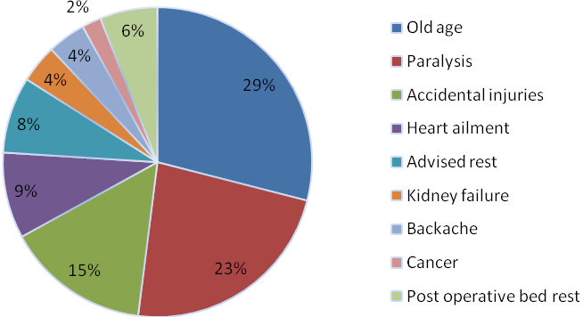

EXISTING SYSTEM

Senior hospital Namyangju,Korea provide suitable environment for senior patients real time monitoring and alarm to staff for any emergency condition for elders by tracing location and amount of movment to guarantee health and safety.

In U.S. Department of Health and Human Services: Administration for Community Living (ACL) has introduced a device for old people where Wireless sensors throughout his house help measure healthy activity levels, sleeping patterns and medication schedules.

Aerocrine’s NIOX MINO creates exhaled nitric oxide (NO) monitoring devices that provide data about asthma for research and clinical applications.

PROPOSED SYSTEM

The architecture of the system is based on the integration between WSNs and web server to provide an automated smart health system.
Sensors are used to measure the physical parameters of the patient such as heart rate,Body Movement and Temperature.
These sensors transfer data from patient's body over the wireless network to the web server using open hardware like Arduino or Raspberry Pi.
This system notifies nearby healthcare providers, ambulance services and inform relatives of patient’s info in case of emergency without time delay.
The values of sensors are monitored and updated continuosly in the webpage.
If the patient is in critical stage we inform the nearby ambulance service through GSM and by standers are alerted by an sms.

PARAMETERS MEASURED

The movement of the patient (using accelerometer)
Temperature (using LM 35)
Pulse and Oxygen rate in blood(SPO2)

ADVANTAGES
Real time monitoring of bedridden patients at home to overcome delay in access to health care services.
Since the whole system is automated it provides assistance of medical staff only when required
Reducing manual data entry of patients data by medical staff.

SYSTEM ARCHITECTURE

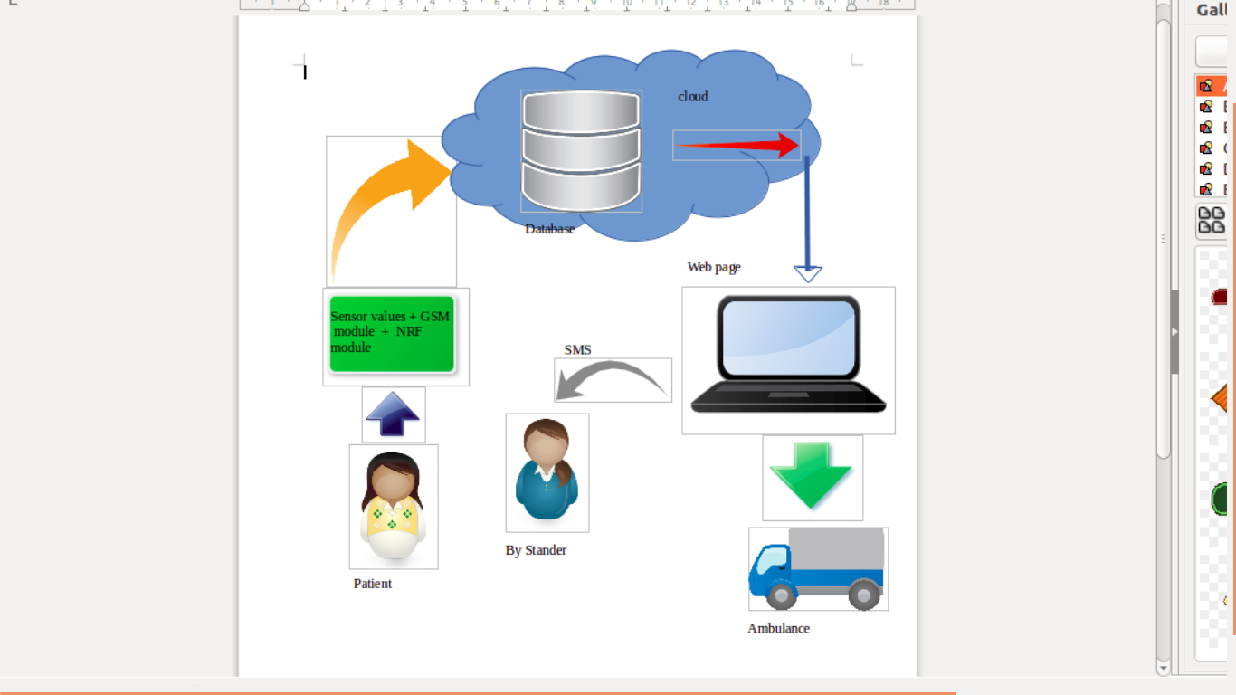

HARDWARE CONNECTION
The system contains two secions.
Wireless Transmission Module
The transmitter block collects the sensor values and send it to the reception module over an NRF module.
The main parts in the transmitter section are
Arduino AtMega 2560
Wireless Sensors( Accelerometer, Temperature, Pulse rate,NRF Module (Transmitter)
GSM module
Wireless Reception Module (Internet-enabled)
This reception module receives sensor data through NRF module and sends it to cloud.
This block contains parts such as
Arduino Uno
NRF module (reception)
ESP module

WEB PAGE
http://www.smartnodes.in/sc/ is the webpage created for hospitals.
The webpage contains transmitted sensor data of each patients, details of doctor and the patient's medical history.

REFERENCE

- www.arduino.cc
- www.instructables.com
- A Cost effective Arduino Module for Bed-ridden patient’s Respiratory Monitor and Control-Sankar Kumar S , Gayathri N , Nivedhitha D , Priyanka A S
- A Smart System Connecting e-Health Sensors and the Cloud-Mohammad S. Jassas, Abdullah A. Qasem, Qusay H. Mahmoud

